

Caption ID of Parent: 110303

Source: Photodisc

Source ID: OS19096

Rights Type: Royalty Free

Credit: © Photodisc

K12 Credit: Blue ribbon. © Photodisc

RM Assets Embedded: No

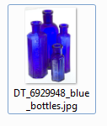

Caption ID of Parent: 1190468

Source: Dreamstime

Source ID: 6929948

Rights Type: Royalty Free

Credit: © Dreamstime.com

K12 Credit: Blue bottles. © Dreamstime.com

RM Assets Embedded: No

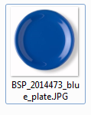

Caption ID of Parent: 116541

Source: BigStockPhoto

Source ID: 2014473

Rights Type: Royalty Free

Credit: © jose schirado/BigStockPhoto.com

K12 Credit: Blue plate. © jose schirado/BigStockPhoto.com

RM Assets Embedded: No

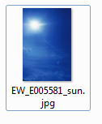

Caption ID of Parent: 113646

Source: EyeWire

Source ID: E005581

Rights Type: Royalty Free

Credit: © Eye Wire

K12 Credit: Blue sky. © Eye Wire

RM Assets Embedded: No

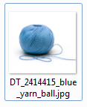

Caption ID of Parent: 219141

Source: Dreamstime

Source ID: 2414415

Rights Type: Royalty Free

Credit: © Hannu Liivaar/Dreamstime.com

K12 Credit: Blue yarn. © Hannu Liivaar/Dreamstime.com

RM Assets Embedded: No

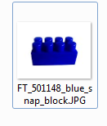

Caption ID of Parent: 118432

Source: Fotolia

Source ID: 501148

Rights Type: Royalty Free

Credit: © Aidairi/Fotolia.com

K12 Credit: Blue block. © Aidairi/Fotolia.com

RM Assets Embedded: No

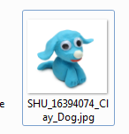

Caption ID of Parent: 1471084

Source: Shutterstock

Source ID: 16394074

Rights Type: Royalty Free

Credit: © Elena Schweitzer/Shutterstock.com

K12 Credit: Blue clay dog. © Elena Schweitzer/Shutterstock.com

RM Assets Embedded: No

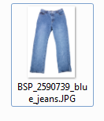

Caption ID of Parent: 116548

Source: BigStockPhoto

Source ID: 2590739

Rights Type: Royalty Free

Credit: © feng yu/BigStockPhoto.com

K12 Credit: Blue jeans. © feng yu/BigStockPhoto.com

RM Assets Embedded: No

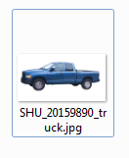

Caption ID of Parent: 1346788

Source: Shutterstock

Source ID: 20159890

Rights Type: Royalty Free

Credit: © L Barnwell/Shutterstock

K12 Credit: Blue truck. © L Barnwell/Shutterstock

RM Assets Embedded: No